Microsoft Teams Live Event SOP

1. **Schedule Live Event**

* In Microsoft Teams Click on Calendar and then click **+New Meeting** tab.

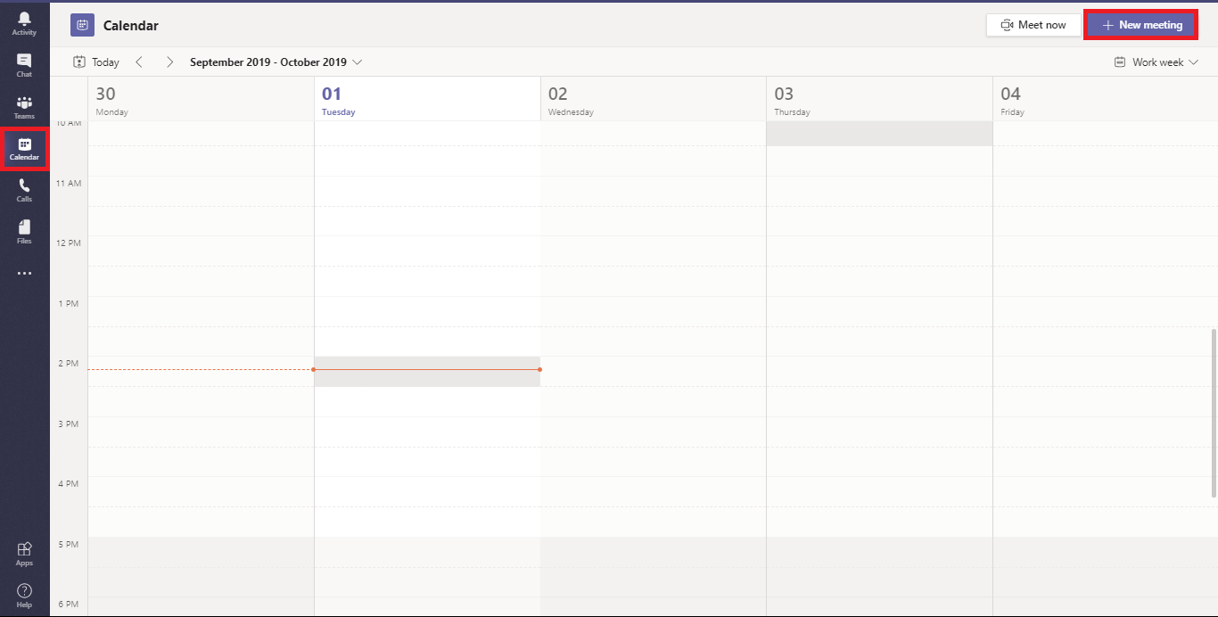

* After Clicking on New Meeting. Click on Drop Down Arrow and select New Live event.

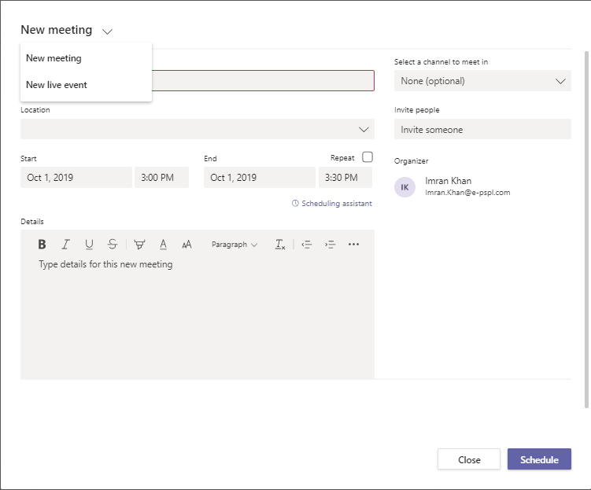

* Here you can Fill all the required details and invite Presenter or Producer for the Live Event. And click Next

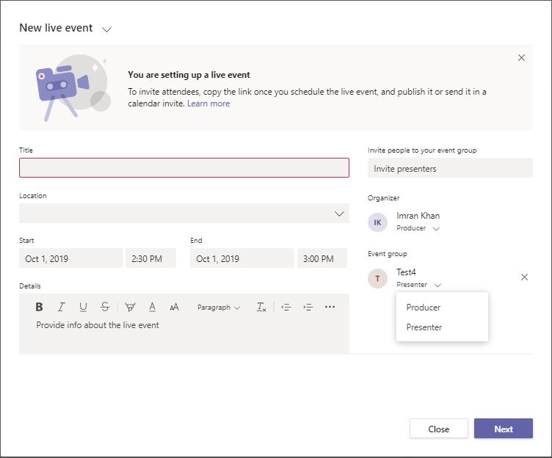

* Here you can give Live Event Permission. (**Note**: Public Live Event is disabled by default and can be enabled from the Teams Admin Center via Live Event Policies)

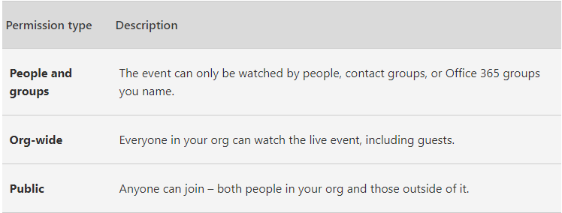

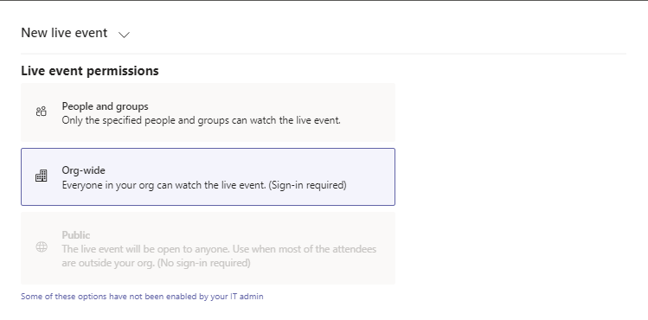

* Here you can select how you are going to produce your Live Event. And Select Schedule

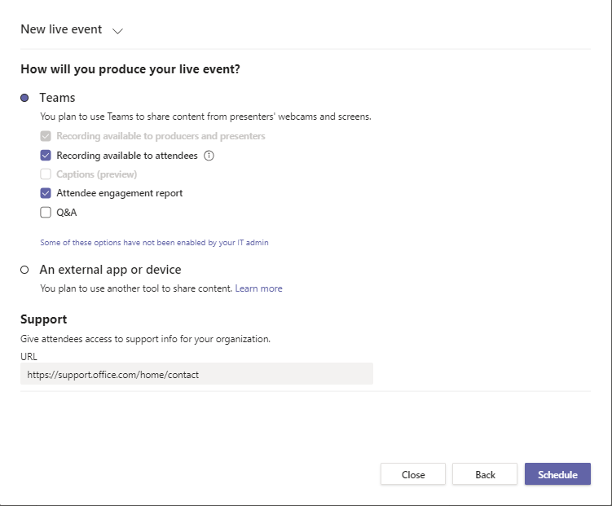

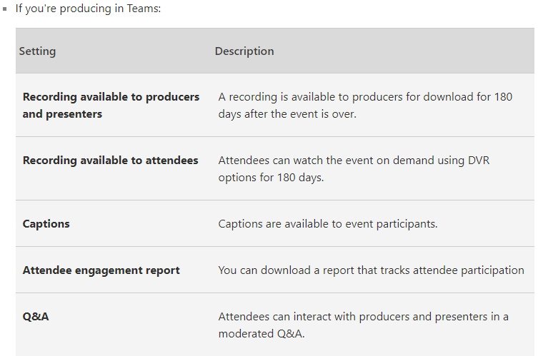

* Click on Get attendee link this will get copied to clipboard. And close this.

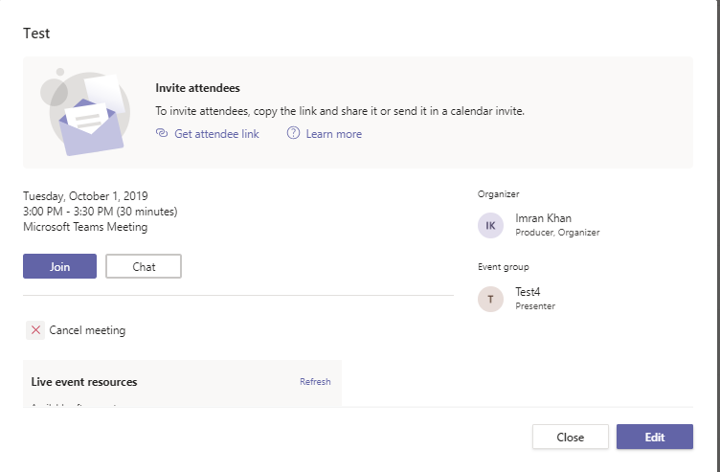

* Once the Live Event is schedule you can share copied link with attendees as you see fit—send it in a Teams channel, an email, a Communication site on SPO. You could even send it in a calendar invitation from Outlook which ensures that it sits on the attendee’s calendars.

# Producer Screen

When producer clicks on Join meeting from his calendar.

Click Join Now here.

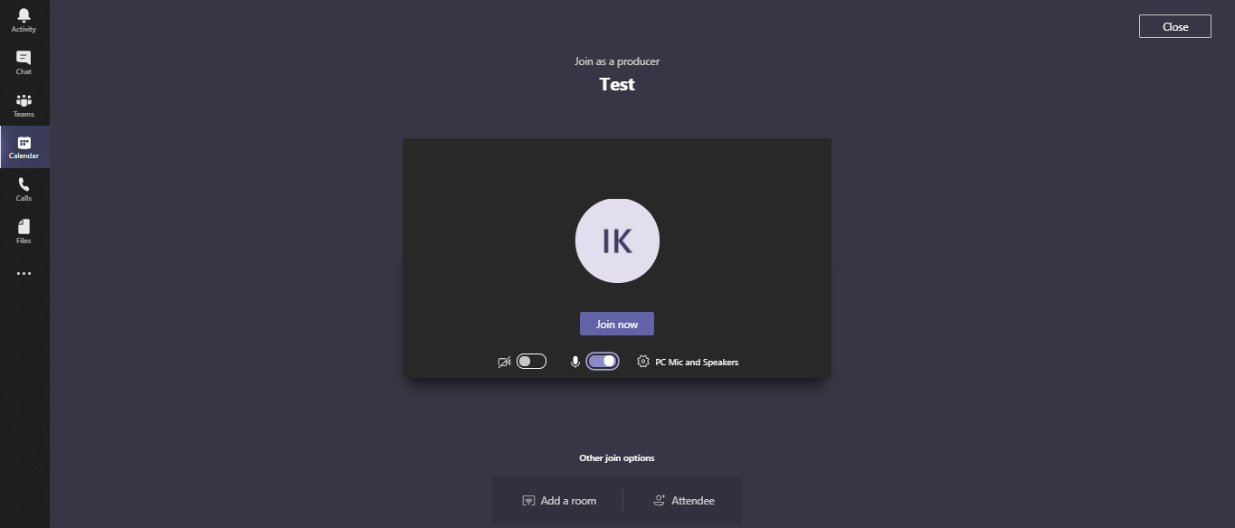

* Once Producer is in the event, he is greeted with the below screen. Left Screen is for Video and Content and Right Screen is the Final preview which the attendees will see.

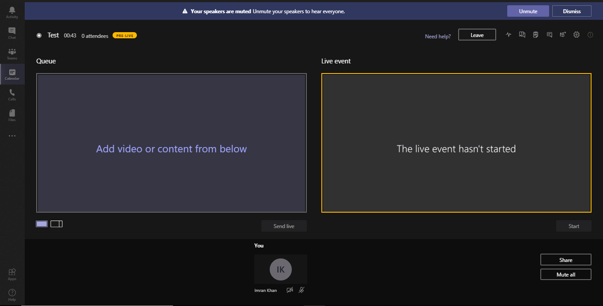

* Here Producer will get option to choose what he want to share and send Live. Only Video or Content or Both. (Below is the ScreenShot)

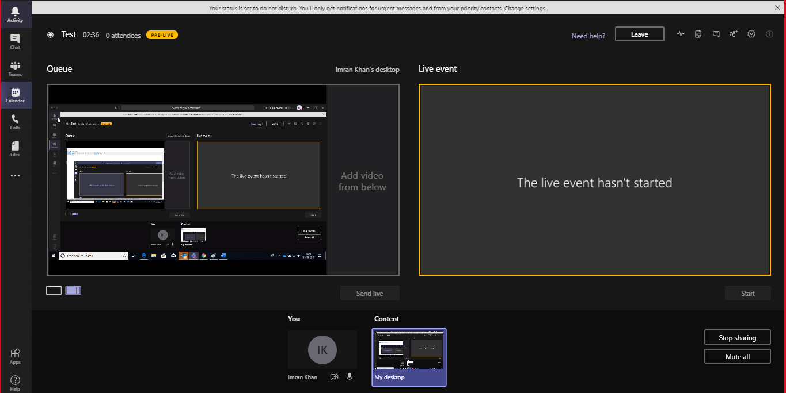

* After sharing the content Producer will have to click on Send Live. (Below is the screenshot the content on the right side will be displayed to Attendees)

**Screenshot with Content Only**

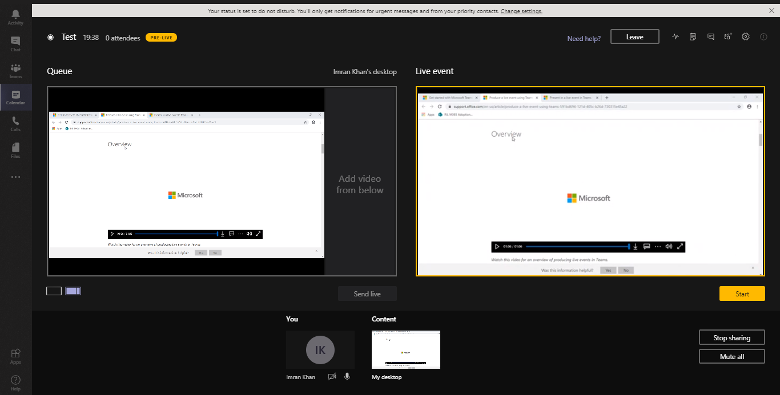

**Screenshot with Both Content and Video**

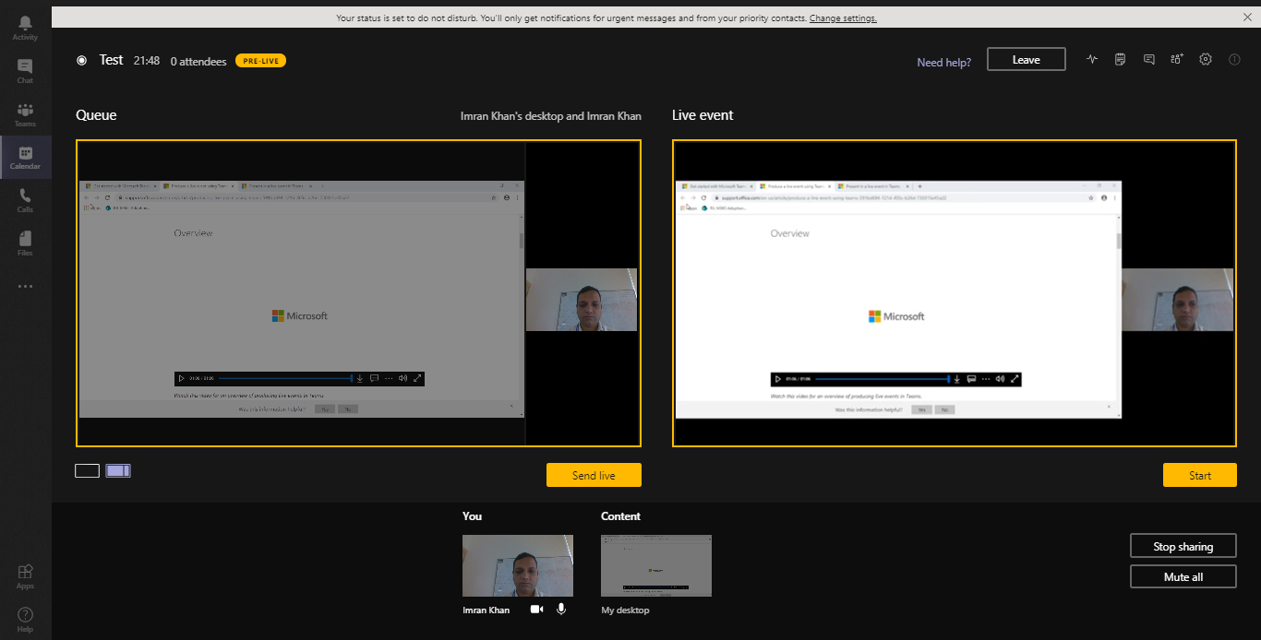

* Once Producer and Presenter decide to commence the broadcast hit **Start**. Hit Continue to begin.

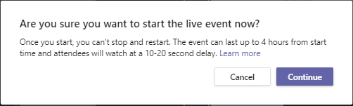

* Live Event Broadcast started.

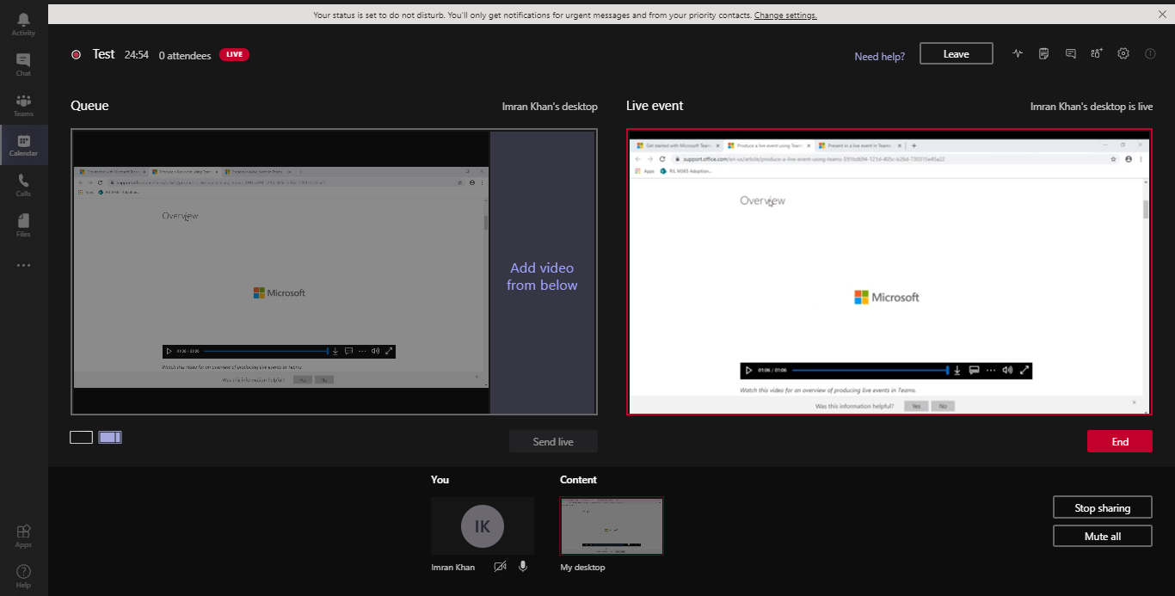

* Producer can make announcement during the Broadcast by using the “Make Announcements” option which is part of the QnA Panel on Right upper corner of the event.

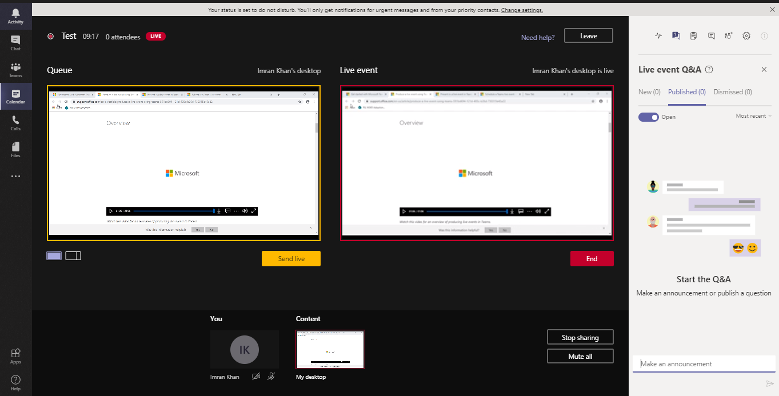

* Producer will have the option to Published or Dismissed the question
* Producer can do One on One Chat with Presenter
* Producer can take notes of the meeting

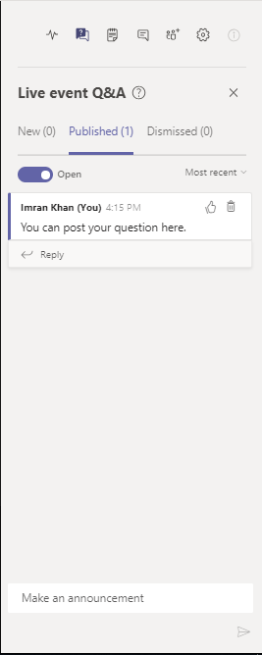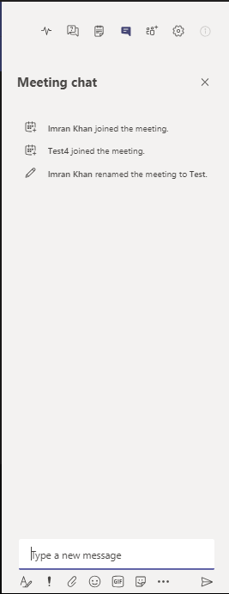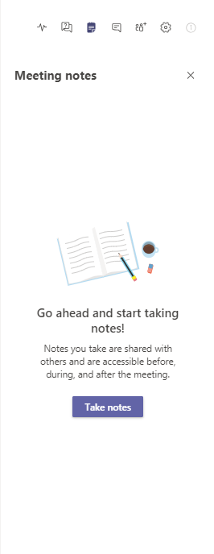

* Once the Live Event is Ended the Producer can click on the calendar invite and get the Live Event Resources downloaded (Resources will be available for 180 days)

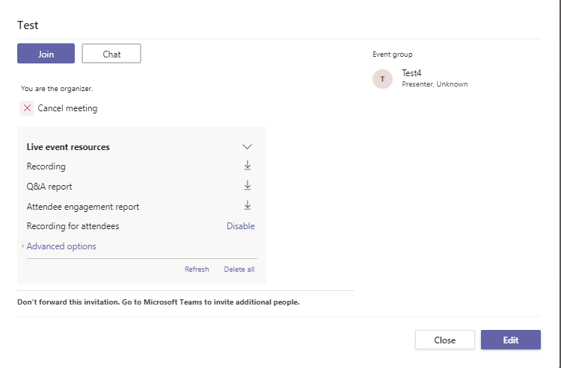

1. Recording can be downloaded and uploaded to Stream.
2. Q&A Report shows a detailed summary of the Queries asked and the response provided.
3. Attendee engagement report- Shows who attended the event and which device they used.
4. You have an option to disable / enable the recording post the event as and when necessary.